|  |
| --- |
|  |
| Functional design |
| *Fasten your seatbelts* |
|  |

ITopiaLogo

*Datum: 08-12-2014*

*Klas: IN-102 team 3  
Versie: 0.5*

*Naam stud: Jasper Nota*

*Naam stud: Jony Zeitoun*

*Naam stud: Sjors de Haan*

*Naam stud: Talitha Wingelaar*

*Naam stud: Ward v/d Meulen*

Contents

Preface 3

General 3

Background 3

Our task 3

Content 3

Current situation 4

Desired situation 4

The Network infrastructure 6

Consequences 8

Management summary 9

# Preface

## General

This Functional Design is to explain the functional requirements in our project, to make wireless internet available in the airplanes of Corendon. At this moment, there is no internet connection available in the airplanes and Corendon would like to offer this as a service.

## Background

Corendon has asked us to develop a project that would offer a wireless internet connection to their customers on their airplanes. Corendon wants to do this to offer an extra service to their customers, and to keep up with the competition. Some are already offering wireless internet in their airplanes, Corendon would like to do the same.  
  
How we are going to do this will be explained further in this document. This will be done at a functional level. For the technical specifications and further explanation, please refer to our Technical Design.

## Our task

The current world is a digital world, pretty much every customer of Corendon nowadays has devices that connect to the internet. Customers often take these devices with them when they travel to their destination and they would like to use these devices in the airplane already. This has created a need for internet availability on the airplane.

## Content

The functional design consists of the following sections:

1. Preface
2. Current situation
3. Desired situation
4. Consequences
5. Managementsummary

## Current situation

Corendon Dutch airlines is a Dutch branch of the Corendon group (which also operates as Corendon airlines in Turkey) which started operations under its own AOC in April 2011 using a single Boeing 737 aircraft serving European holiday destinations from Schiphol airport. Currently Corendon’s fleet contains 12 aircraft.

Momentarily there is no internet access on board of the Boeing 737’s that Corendon flies with. This causes discomfort for passengers who want to check their e-mails and/or update their Facebook statuses. Since the internet has become more important in our daily lives.

Corendon has asked us to provide them with a solution to bring internet to their passengers.

What we have done is create a business case, functional design and a technical design of how we think a good network would look like on board of the airplanes. We will continue to enhance the documents made on project “fasten your seatbelts” as we make progress.  
  
Currently, there is no wireless internet connection on board. Customers cannot use their devices to connect to the internet, and there for cannot use internet services on their devices.

## Desired situation

**Description of the new system**

*The input*

We will use several minicomputers spread throughout the airplane for continuous and stable reception. These minicomputers will all run software for connections, security and logging of data, which will all be discussed in technical detail in the Technical Design. The customers can connect to a wireless network and need to log in for security and identification purposes and he also has to accept the terms and conditions of Corendon.

Client PC Raspberry Pi Captive Portal Internet

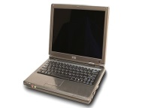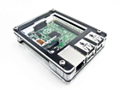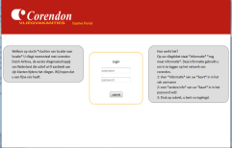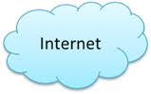

**EXAMPLE:**

The passengers will all get a username and password that is connected to their boardingpassnumber. When a passenger would like to connect to the internet with his device, he will get redirected to the captive portal, where he has to enter his username and password. When the login is successful the passenger is granted access to the internet.

*The output*

A stable wireless network that will handle a wireless connection in a constant manner, without interrupts or delays. Also, the network will be fast and will be able to handle internet-requests without waiting time. The wireless network will be servicing one device per passenger. The passenger will be able to use the internet under the terms and conditions of the Corendon Airline staff.

## The Network infrastructure

*Hardware &additional systems*

As described earlier, we will use several minicomputers (Raspberry Pi) that will be connected to each other to operate as one wireless hotspot. The devices will be spread around the airplane to ensure the entire airplane will have good reception of the wireless signal. The minicomputers will use wireless hardware to transmit the networking-signal to and from the devices.   
  
The network infrastructure will be a complex and technical set-up, which will be further discussed in our Technical Design. For additional details, please refer to this document.   
  
*Services we will deliver:*   
in the desired situation, the following functionalities have to be offered:   
  
  
***1. Fast and stable internet connectivity to customers’ devices***  
  
The Raspberry Pi is a proven and well tested device which’ hardware is very reliable. In terms of software, the devices will all run Linux, Apache Tomcat and other very stable and reliable software to ensure the system will keep on working the way it was meant to be. The software will be configured with care so that the configuration will run smoothly without any hiccups or bugs. To ensure this will happen we will test the entire project thoroughly.   
  
For additional information regarding the stability of the project, especially technical information about software and hardware, please refer to the Technical Design.  
  
  
***2. Data-logging abilities***  
  
In addition to previously mentioned stability, it is needed to “log” certain information about the system itself and the passengers connected to it. This is to ensure the system will be able to provide additional services to the passengers and also for legal reasons (for example, if the passenger conducts any illegal activity via the Wi-Fi of Corendon, like online crimes).   
  
It is also needed to keep on logging information about the system itself so its maintenance becomes easier and issues can be troubleshooted more effectively.  
  
For additional information about how we will log and which information we will be logging, especially technical details, please refer to the Technical Design.

**3. Secure environment, with management capabilities**  
  
It is important the passenger feels safe while using the wireless network. Passengers will most likely use online services that contain personal information about themselves and others (websites like Facebook and online email). To ensure this information does not fall into the wrong hands, we need to make sure the connection is a secure connection and all logged information (as described in previous paragraph) will be saved securely.   
  
For example, this means using an encrypted wireless network (which is password protected) and using firewall software.   
  
For specifications about the wireless network and the design of the firewall, please refer to the Technical Design.  
  
  
**4. Reliable infrastructure that will remain working, even if some components fail.**  
  
As always with IT, sooner or later, a problem will arise. This could be anything including a security leak, a reception issue, data loss, etcetera. Nothing is 100% safe and no IT system is 100% stable. Still, it is very important to setup the project so that it will work as reliable as possible.   
  
First of all, this means backup solutions that will take over tasks of failed hardware and/or software. If one component fails, there is another component that will take over so that the system as a whole will receive minimal impact. Backup can mean two things.   
  
First of all, there is data backup, so in the event of a storage failure the data still exists. It also means some hardware components will need to be implemented twice, so that a secondary device can take over if the primary device fails (the secondary devices provide as backup). This makes the system “redundant”.   
  
For details and specifications on how we will make sure data and systems are made reliable, please refer to the Technical Design.

## Consequences

**Organizational consequences**The consequences of such a system will bring extra maintenance. The extra hardware and software will have to be maintained, which would mean extra maintenance time and extra costs to keep the airplane on the ground.  
  
There should also be a technician on the ground that can perform those necessary maintenance-tasks. The maintenance of the system is out of scope for this project, after the project is implemented and approved by Corendon, Corendon is responsible for making sure the system is maintained. For Corendon, this means it has to acquire a technician that will perform the necessary tasks.   
  
This could mean:   
  
- Schooling current technicians so that these technicians will have the proper knowledge   
 for doing the extra maintenance.  
  
- Hiring additional technicians with the proper knowledge.

This could provide additional costs on top of the project’s cost. These costs will be regular and recurring as the system will need to be maintained on a regular basis to ensure it will work properly.   
  
  
Technical consequences  
As previously mentioned Corendon might not have the necessary know-how to make sure the entire system will be properly configured and maintained. Because the airplanes will have a different (more complex) technical setup, more work and knowledge is required.   
  
The airplanes will have to be installed with the necessary components; this will take quite some time to setup on all of the airplanes. Also, in the event some components of the project will have to be replaced, it is Corendon’s responsibility to do so and configure the components to make sure it behaves correctly.

## Management summary

In this chapter the functional specifications of the system are presented to the management staff of Corendon. In this chapter we will explain all our choices and why we have made these choices.

Corendon asked us to provide their airplanes with Wi-Fi that will be used by the customers of Corendon. In this way they can provide their customers with an extra service.

We were also asked to provide the internet connection with a captive portal, this is a site where you have to log in first, before you can use the internet. In this way the people that use the internet connection can be monitored and they will have to accept the terms of agreement.

- First, four tiny computers are needed, the Raspberry Pi’s. This Raspberry Pi will be the access point for all customer-devices that are connected to the internet. It will be used as an access point. The reason we have chosen the Raspberry Pi is because it's a cheap and easy to manage device.

- Second, two satellites are needed to provide the Raspberry Pi’s with an internet connection. We have chosen to use satellites because this system provides the most reliable service for the airplane, so it won’t be very common that the connectivity will be lost.

- Third, a load balancer is needed. The load balancer makes sure that when one of the two satellites malfunctions, the other one provides as backup. This will make sure that the internet-connection will remain functional when errors arise, to make sure the customers will keep their service at any cost.

- Last, an external battery is needed to charge the Raspberry Pi’s. With the external battery, the Raspberry Pi is able to be charged without a connection to a power socket. This makes sure the setup is very flexible, portable and easy to maintain.

## HTML accessibility

In this chapter we’ll be taking a look at the HTML front-end on a desktop and the design choices that were made.

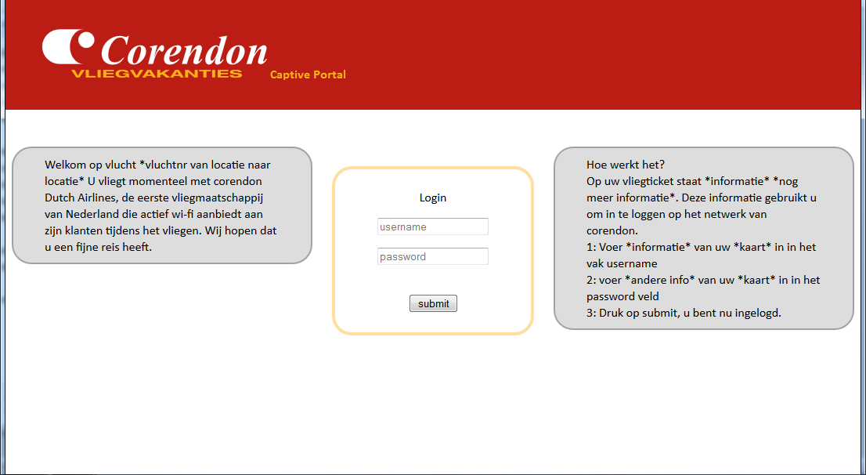

When we were building the HTML page, we choose to use the same layout that is being used on the Corendon site. See [www.Corendon.com](http://www.Corendon.com) for the layout. The reason behind our choice was to bring a simple looking environment, so the user will not experience any difficulties connecting to the internet.

The HTML page in itself is rather simple looking with the intent of making it as easy and fast as possible for the user to log in and make use of the internet. The moment a user connects to the Corendon airlines WI-FI station and opens his browser he’ll be immediately redirected to this page. Once he lands on this page the boxes on the sides of the log in form offer him information regarding the log in process. After filling in the username and password (*Temporary names)* forms, the user will be instantly redirected back to the page on which he previously was

If the user enters faulty information he’ll stay on the current page and a warning message will pop up saying “*The information entered in the username or password field is incorrect, please try again”*. After this the person can try entering the information again and if filled in properly this time he’ll be once again redirected to his starting page from which he arrived.

Another feature that will be added is a language function, a little tab in the bottom corner will contain flags of certain countries and clicking that will change the page to the desired language. For example; the page starts on the Dutch version if a person is flying from the Netherlands, but the user wants the page in English. The user can change this by just pressing the small British flag which will be present in the bottom corner and the whole page will become English as to make the log in process easier for this user.

## Accounts

In this chapter we will be looking at the various accounts that can access the internet.

First let us take a closer look to who will be connecting to the internet.

* Passengers
* Stewardesses and stewards
* Pilots and co-pilots
* Network managers

First of all we will have to manage these accounts, in other words we will have to assign certain privileges to the passengers and certain not. As a passenger you should not be allowed to make any kind of changes to the internet connection. Also, each passenger has to get his own form of login. The form that we will be using is the username and password form. The information of the passengers will be found in a database to which the system is connected.

Second we have the stewardesses and stewards. We thought about giving them information on certain passengers. This will make sure that if something bad might happen the staff knows who this passenger is and maybe even if he has any kind of diseases. But this is an extra feature that is up to the Corendon staff.

Third we have pilots and co-pilots. They will be granted standard privileges such as the passengers have. We do not think that the pilots and co-pilots will be using the internet, because they are busy flying the airplane.

In the end we have our network managers. They will be granted all privileges to make sure that everything works and stays working. They are the only ones who have the right to change anything in concerning of the system and network. They won’t be present on every flight.

Before any off the above-mentioned can use the internet, they will have to accept the EULA and login to get an internet connection.